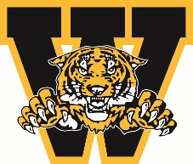
WELLAND MINOR HOCKEY ASSOCIATION
ANNUAL GENERAL MEETING AWARDS
April 2024

JACK BALLANTYNE MEMORIAL COACHING STAFF OF THE YEAR AWARD

Awarded to a coaching staff in Representative Hockey who diligently work together for the betterment of their team, players and families. They embody the WMHA standards, promote respect for all participants of the game, develop players not only on-ice but off-ice as well, and take pride in representing the city of Welland and our organization in a positive way.

You must be a member in good standing to nominate a person you feel is deserving of this award. Please complete the form below and submit to Linda Falovo-Atkinson by emailing linda67atkinson@gmail.com

Nominee’s Name:

Team Associated with:

Nominated by:

Contact #

Why are you nominating this individual? Please give us a brief description and/or overview of why they are deserving.

Signature: ___________________________________________ Date: ___________________________
Deadline for submission March 15, 2024

